Software Deployment AT1.6

30003389 – Kyer Potts

Table of Contents

Table of Contents i

Installing and Creating a Database 1

Connecting to the Database 2

# Installing and Creating a Database

XAMMP is my chosen database server. It is an easy to install package. XAMMP provides multiple features in the form of an apache server and MySQL database hosting.

To download and install XAMMP, go to <https://www.apachefriends.org/index.html> and select the appropriate version for your operating system. Install XAMMP in the desired location and open the control panel to begin the XAMMP web server.

1. Click Start on the Apache web server and MySQL modules
2. Open up a web browser and direct the URL to <http://localhost/phpmyadmin/>
3. Click on the SQL button to open up a dialog box, input the following code to create a database

CREATE DATABASE movies_db

1. Direct the browser to the newly created database by selecting it from the side navigation bar or inputting the following code

USE movies_db

1. To create a table in the database, input the following code

CREATE TABLE `members_table` (

`id` int(11) NOT NULL,

`fullname` varchar(255) DEFAULT NULL,

`email` varchar(255) DEFAULT NULL,

`monthly_newsletter` int(11) DEFAULT 0,

`breaking_newsflash` int(11) DEFAULT 0,

`unsubscribe` int(11) DEFAULT 0

PRIMARY KEY (id)

);

1. To insert data into the newly created table, input the following code

INSERT INTO TABLE members_table (fullname, email) VALUES (Ryan Richardson, [rdr@gmail.com](mailto:rdr@gmail.com));

# Connecting to the Database

To connect to the database via a Java application, the JDBC plugin will need to be downloaded and added to the library files within the project. The JDBC connector can be found at <https://dev.mysql.com/downloads/connector/j/5.1.html>.

1. Once the connector has been downloaded, it can be added to the libraries folder of the project by right clicking on the folder and selecting the Add JAR option.
   1. 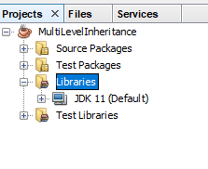
2. Once the connector has been added to the project it will show up in the libraries folder
   1. 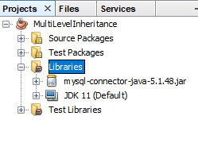
3. Once the JAR file has been added to the library, a connection string will need to be created within the program in order to connect to the database. Use the following code to connect to the database

String url = "jdbc:mysql://localhost:3306/movies_db"; //jdbc, database name and port

String user = "root"; //username

String password = "root"; //password

con = DriverManager.getConnection(url, user, password); // connection string